**REPORT**

**Objective**: Payment Billing Product Project.

**Users of system**:

1. Admin (primarily used)

2. Manager.

3. Student.

**Functional requirement of your user**: Data of personal information of student. (name, add, fee paid, branch etc.)

**Tools used**: Html, sqlite jdbc ,java.

**How project works**:

When we run this programme this admin page will be displayed .

Username- Admin

Password- Pass123

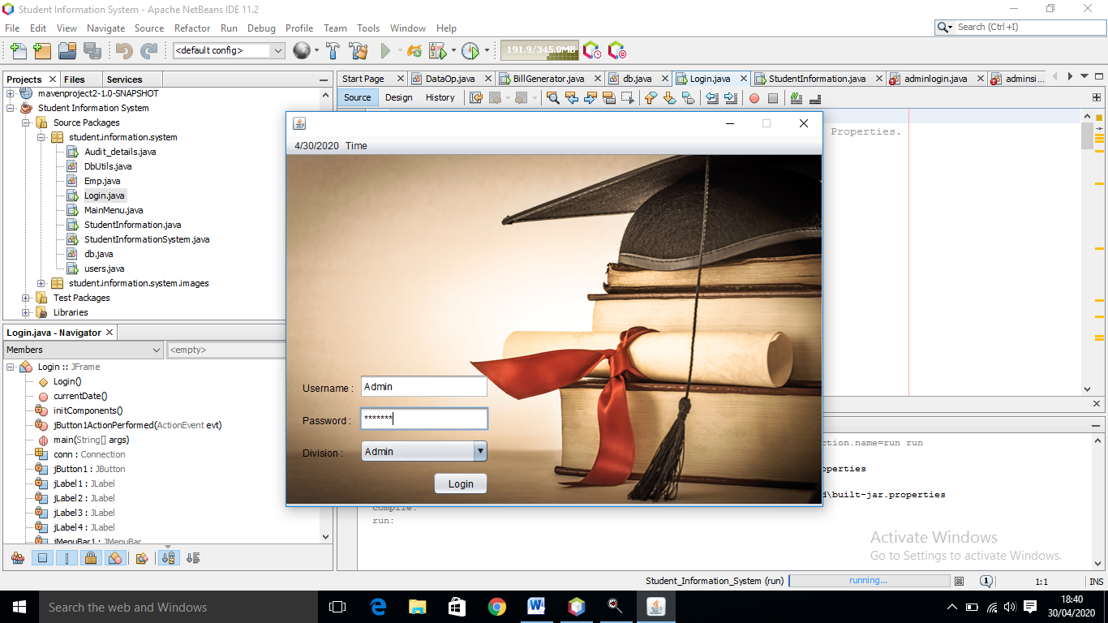

If correct username & password entered then it will show the access to the project.

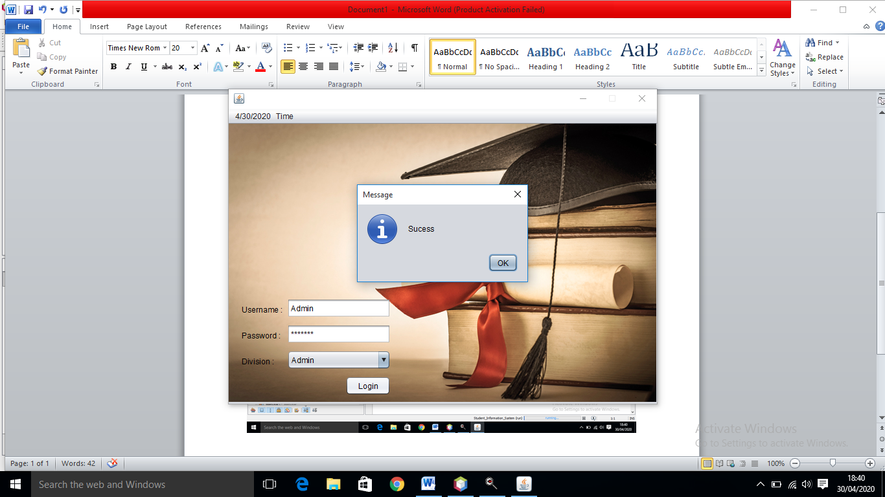

Now in this logged in page , we will click on “ Student Manager”.

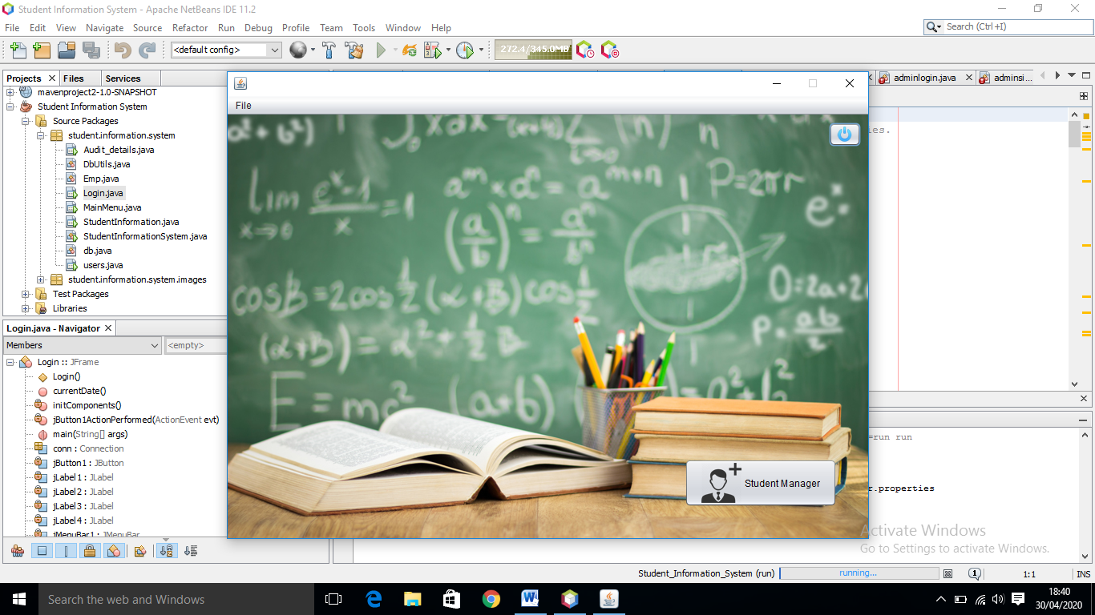

Now we will fill the student information and then add the record.

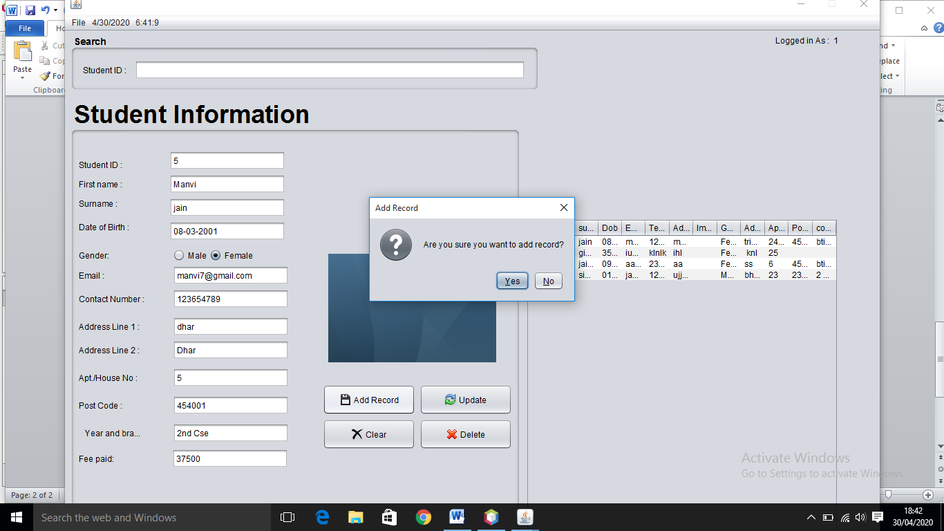

Thennit will display the success box.

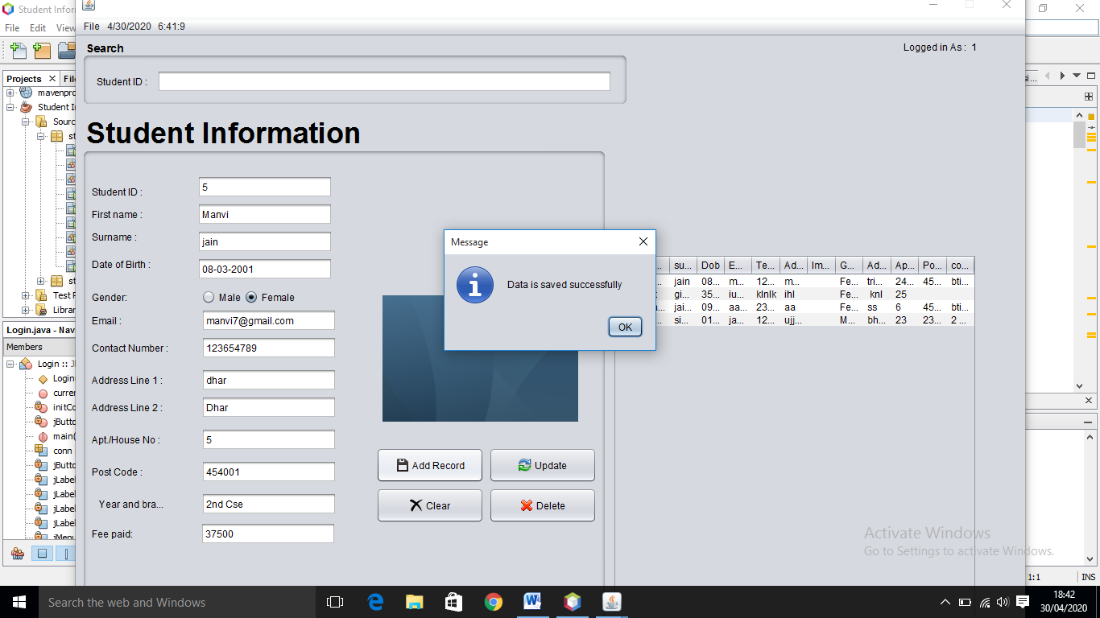

Now by clicking on Audit

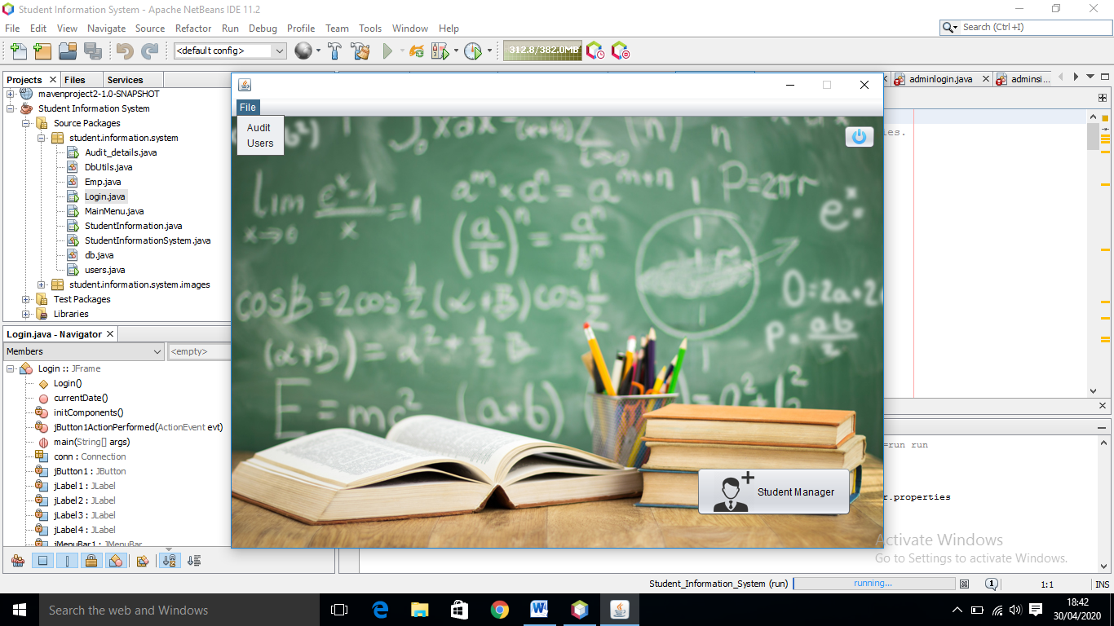

We can see the entire detail of entered student id.

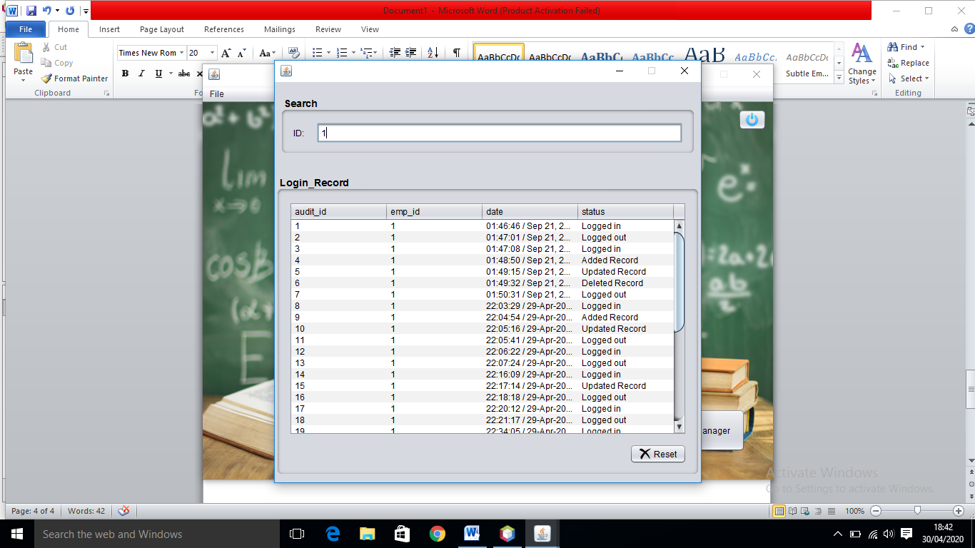

Now in user we can edit our username & password.

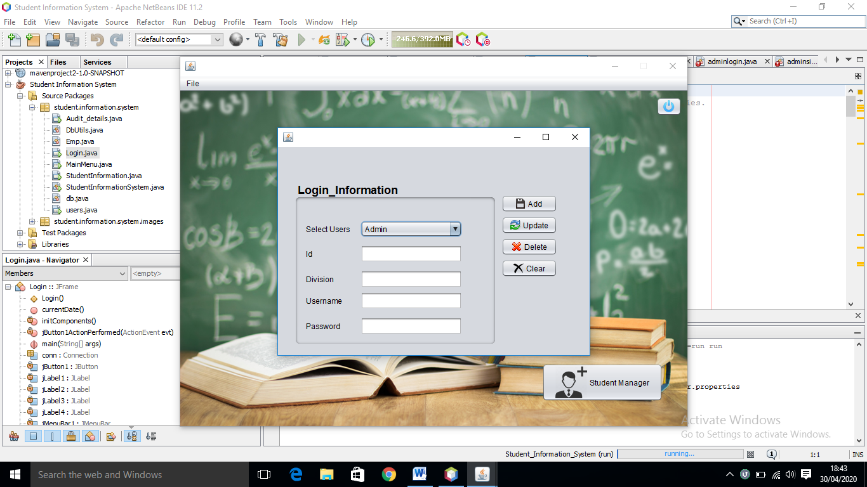

If we want to update any record of student, by entering student id the record will be displayed.

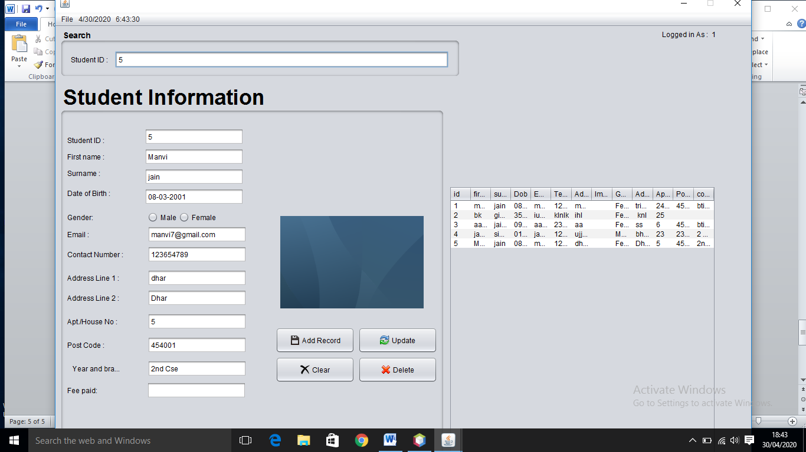

Here I edited first name from manvi to manviii

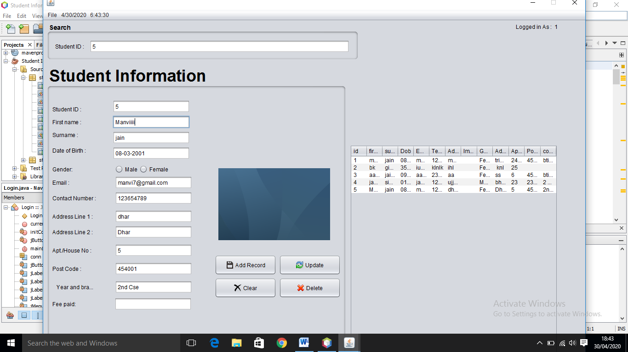

When we click on update this pop up will be displayed.

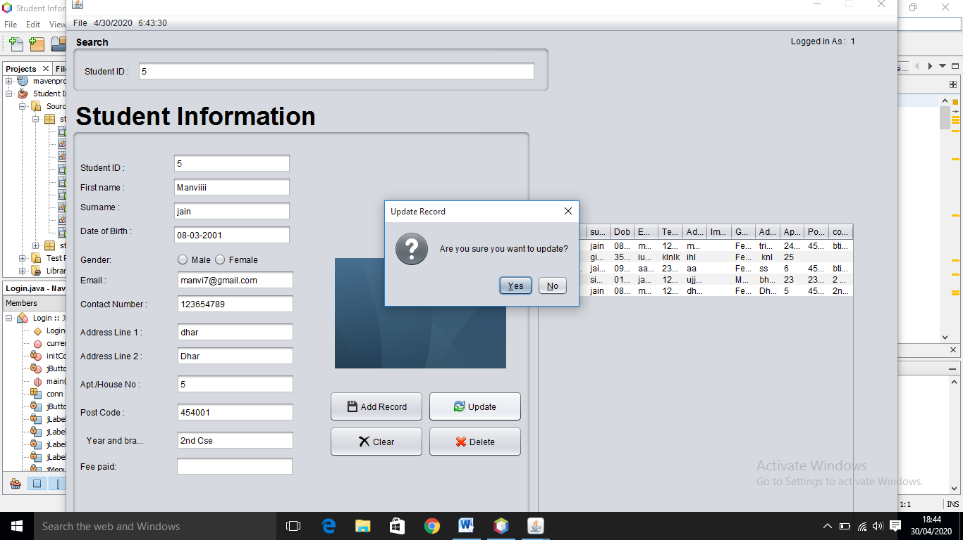

The record has been updated.

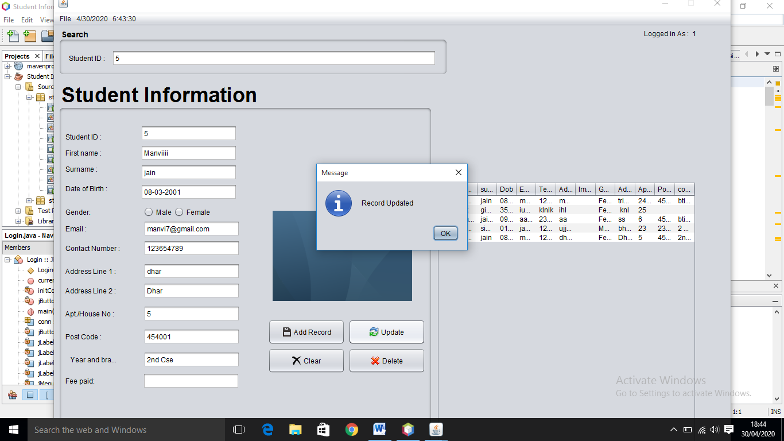

The entire record is shown

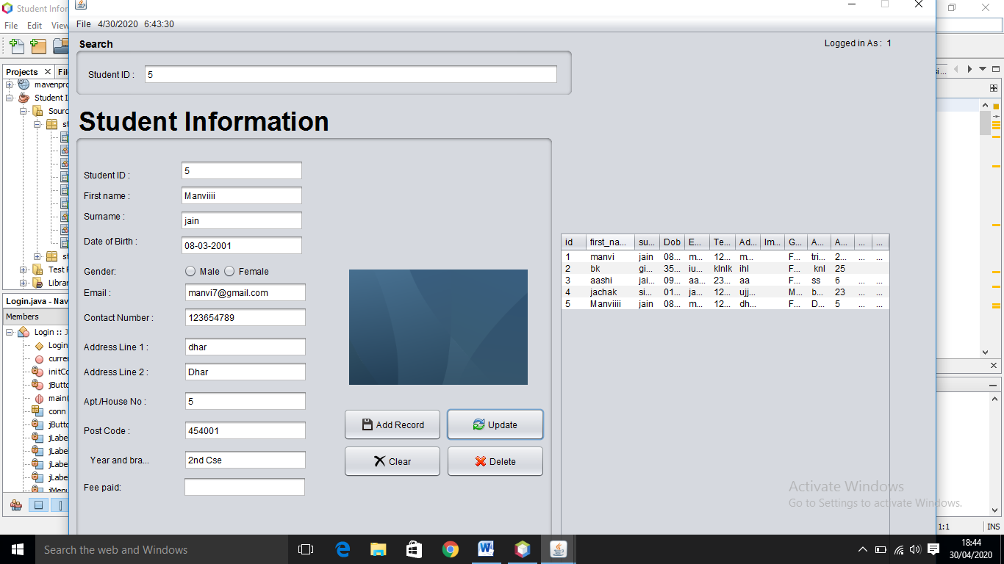

If we enter wrong password , it will diplay the alert message.

